- Create numeric, character, and logical vectors and display type and content.
a <- c(1,2,3,4,5)
b <- c("Ram","Shiva","Vishnu")
c <- c(TRUE,FALSE,TRUE)

print(paste("Type of a : ",class(a)))
print(paste("Type of b : ",class(b)))
print(paste("Type of c : ",class(c)))
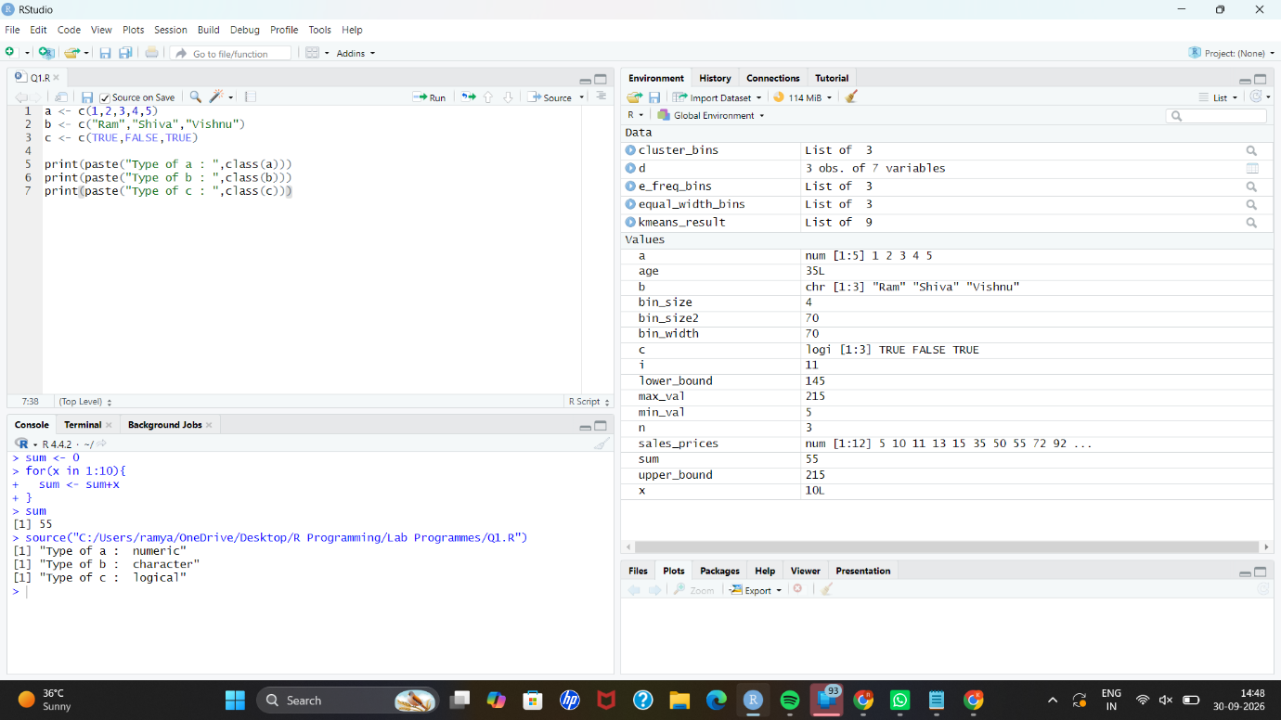

- Create labeled matrices (5×4, 3×3, 2×2) filled by row/column.
a = matrix(1:20,nrow = 5,ncol = 4)
b = matrix(1:9,nrow = 3,ncol = 3)
c = matrix(1:4,nrow = 2,ncol = 2)
a
b
c

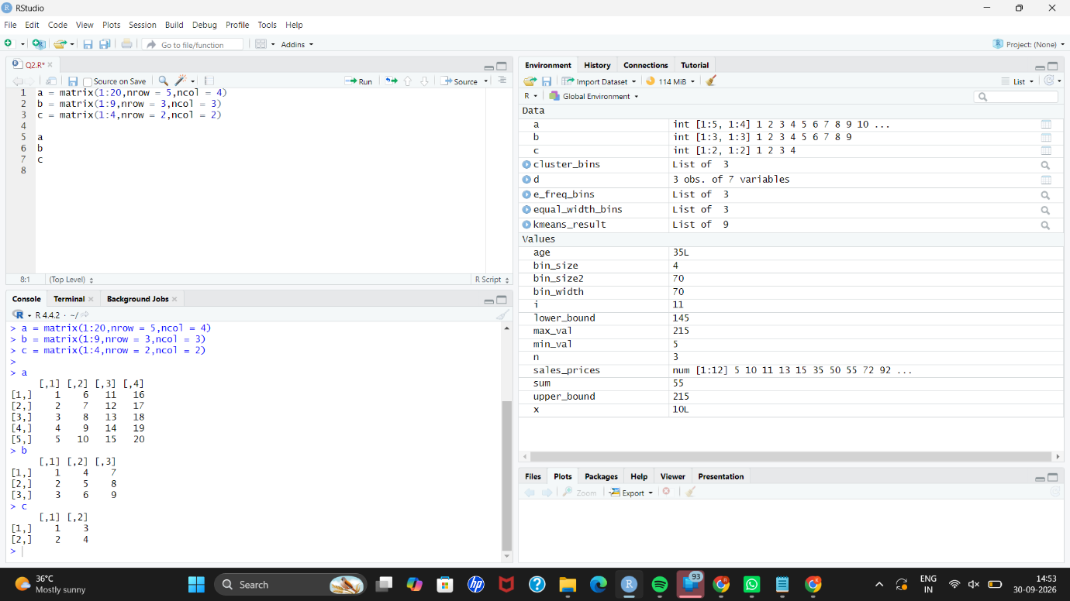

- Write an R program to create and display a 3D array with specified rows, columns, and tables.
a = 1:24
arr = array(a,dim=c(2,3,4))
arr

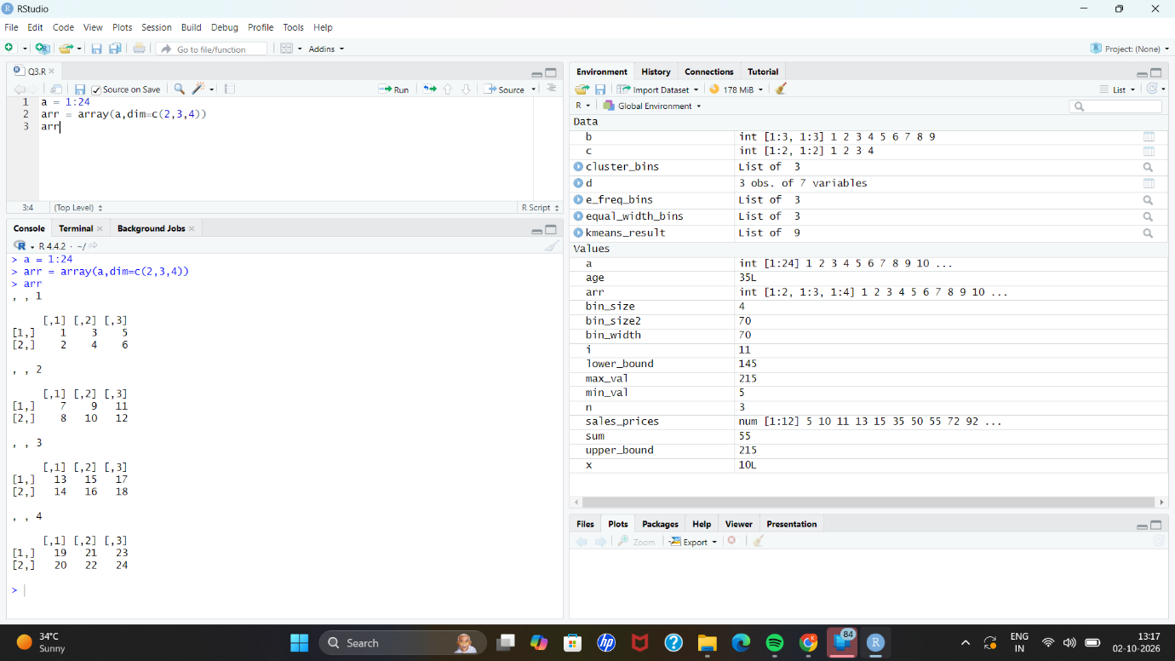

- Create arrays from vectors with dimension names, print specific elements.
a = 1:8
b = array(a,dim=c(2,2,2))
b
print(b[2,1,2])

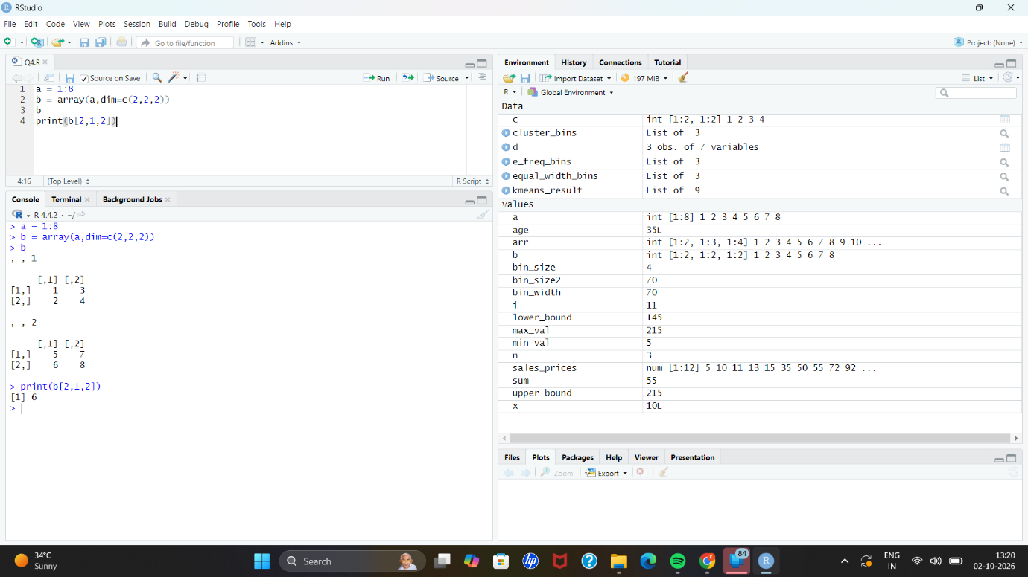

- Create and manipulate factor variables (e.g., women’s dataset heights, random LETTERS sample).
a = c("Short","Medium","Tall","Medium","Tall","Short")
b = factor(a)
print(b)
set.seed(10)
c = sample(LETTERS[1:5],8,replace=TRUE)
d = factor(c)
print(d)

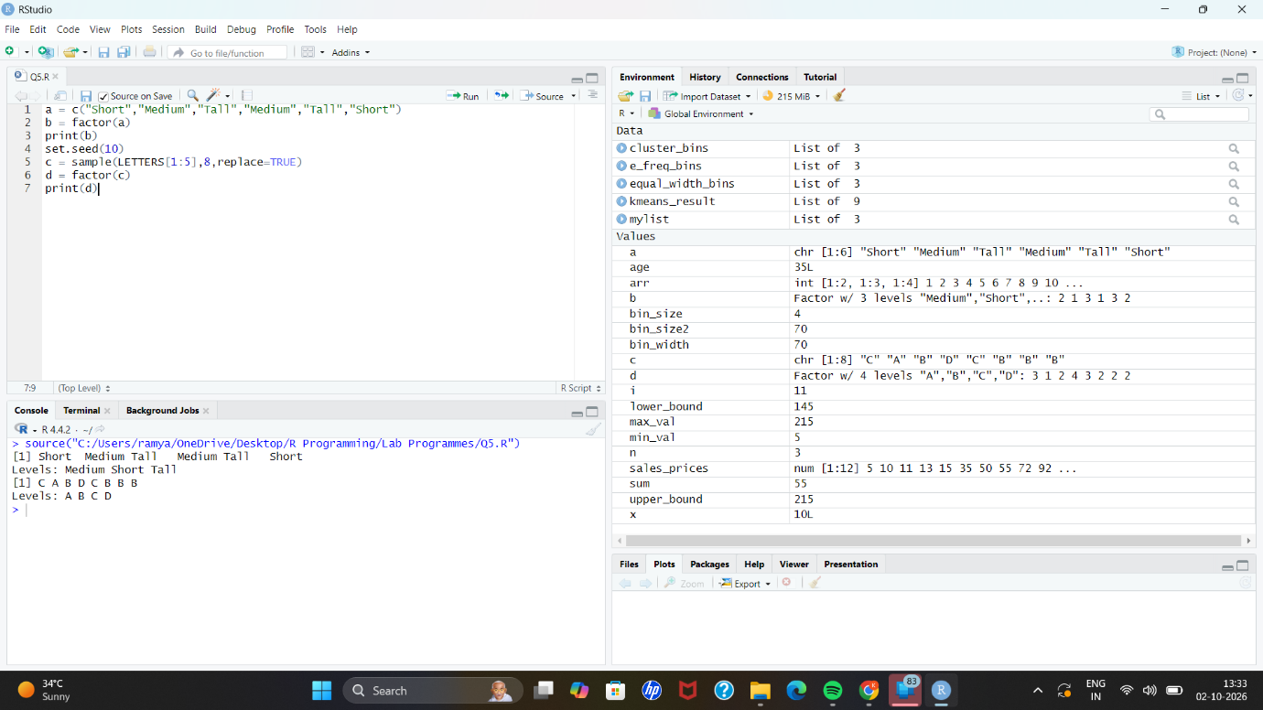

- Create an R list containing vectors, matrices, and functions; display contents
a = c(1,2,3,4)
b = matrix(1:6,nrow=2,ncol=3)
c = function(x) x^2
mylist = list(Vector = a,Matrix = b,Function = c)
print(mylist)

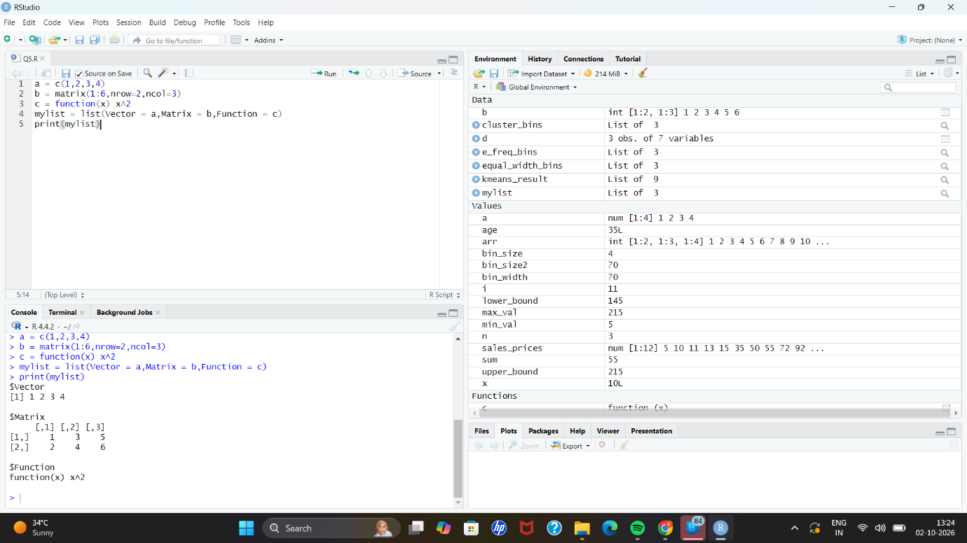

- Write R programs for basic tasks: Factors of a number, generate a vector of 10random integers between -50 and 50, print numbers 1–100 with FizzBuzz logic.
n <- 12L
factors <- integer(0)
for(i in seq_len(n)){
if(n%%i == 0L){
factors <- c(factors,i)
}
}
print("Factors of the number: ")
print(factors)
set.seed(123)
print("10 random integers: ")
print(sample(-50:50,10,replace=TRUE))
for(i in 1:100){
if(i %% 15 == 0)
print("FizzBuzz")
else if(i %% 3 == 0)
print("Fizz")
else if(i %% 5 == 0)
print("Buzz")
else
print(i)
}

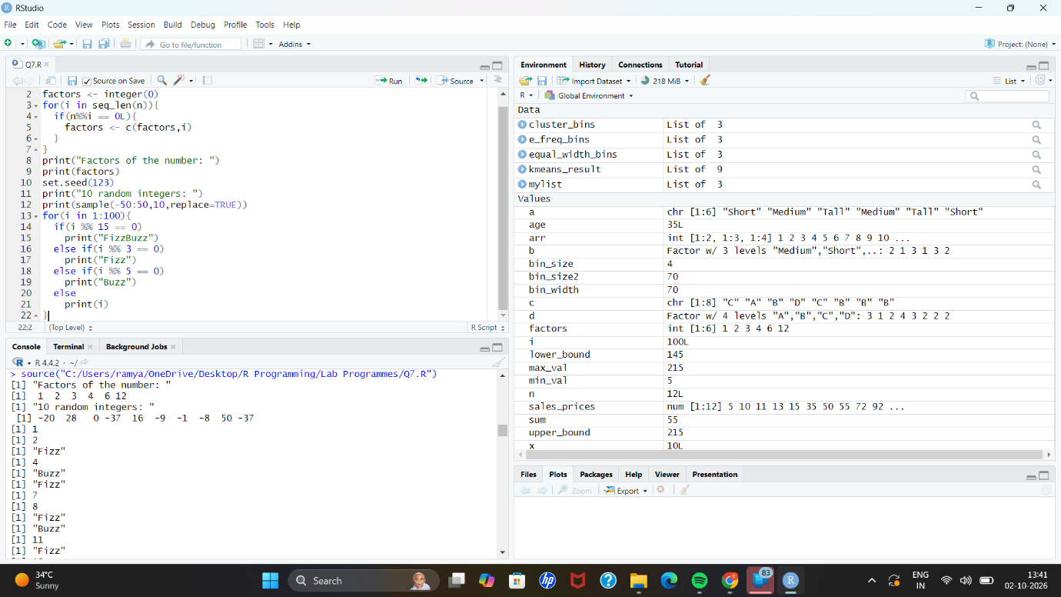

- Generate random numbers from a normal distribution; count occurrences.
set.seed(123)
x <- rnorm(100)
y <- (table(round(x)))
print(as.data.frame(y))

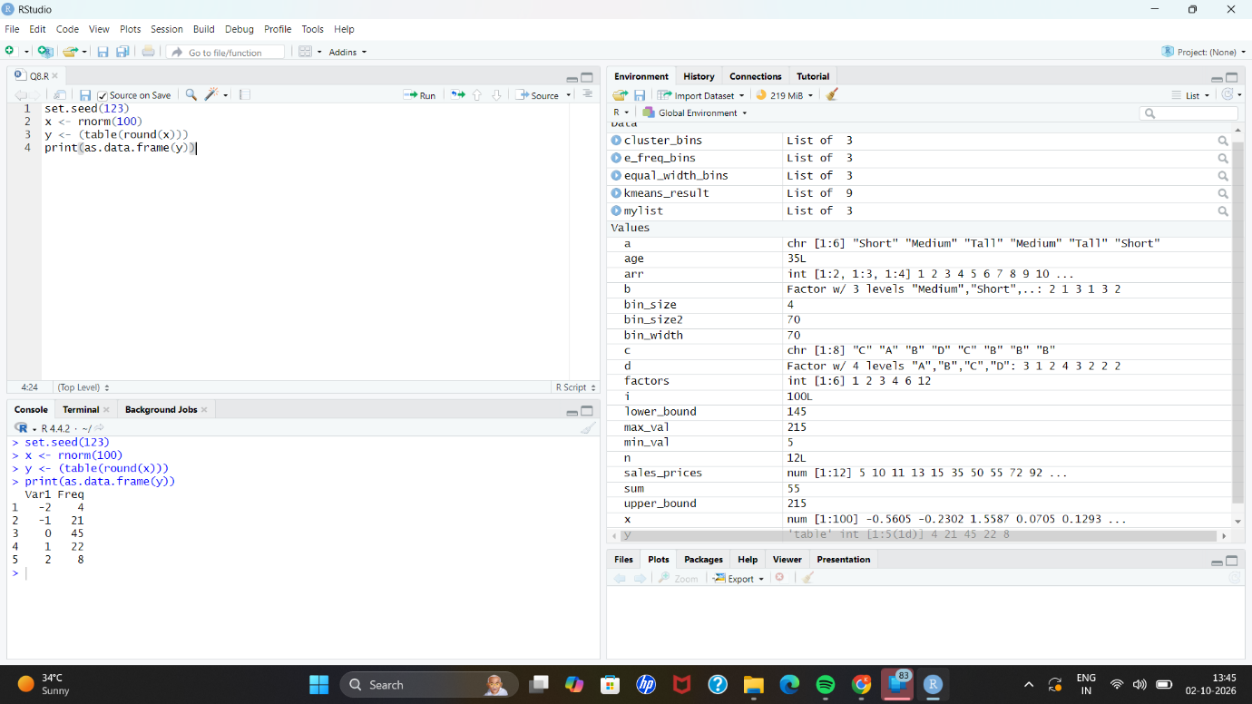

- Create empty plots with specified axis limits.
rm(c)
plot(1,type="n",
xlim = c(0,10),
ylim = c(0,100),
xlab = "x axis",
ylab = "y axis")

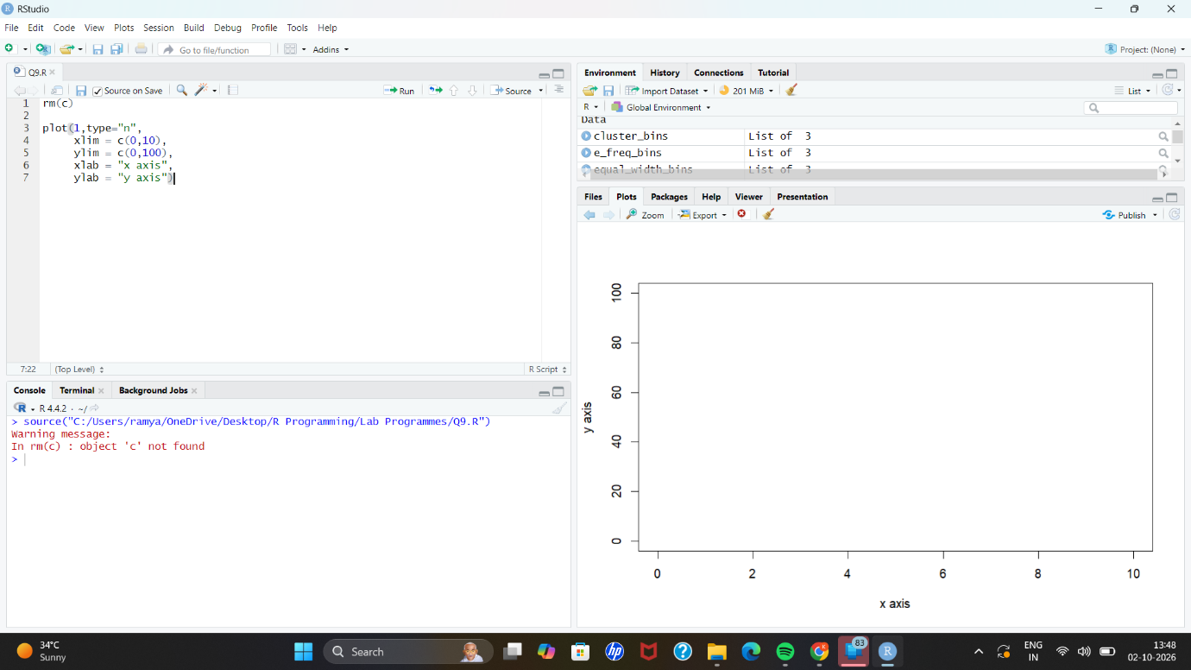

- Create and explore a data frame exam_data with name, score, attempts, andqualifying fields. Perform extract, add row/column, sort, save to file.
x <- data.frame(
name = c("Anu","Bala","Charan","Divya","Esha"),
score = c(85,62,90,75,88),
attempts = c(1,3,2,2,1),
qualify = c("yes","no","yes","no","yes")
)

x <- rbind(x,data.frame(name="Farhan",score=70,attempts=3,qualify="no"))
x$grade <- c("A","C","A+","B","A","B")
x <- x[order(-x$score),]
write.csv(x,"x.csv",row.names=FALSE)
print(x)

